The Urban Cartographer Online
www.eightcitiesmap.com
presents
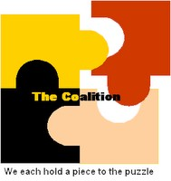
News From
The Coalition, Inc.
Notice:
The newsletter is now available
in .pdf format.

NEWS UPDATE FLASH!
The first Philadelphia Marathon took place in 1994.
We send our condolences to the 2011 Philadelphia Marathon casualties, their families and loved ones.

Updated Edition Coming Soon

We are taking a break this week, but will return on Dec. 2nd.
Enjoy your holiday and Be Safe!

